Laboratory 1 Report WLA
At the same ZIP folder containing this report you can find the MatLab script used in the lab. On the report the conclusions and the graphs can be obtained.

- For the antenna of the pre-work find the directivity numerically using MATLAB.
Following there is the capture of the result obtained in Matlab of the directivity:
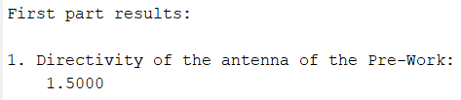
If we compare it with the previous work done at home, we can see that the value coincides:
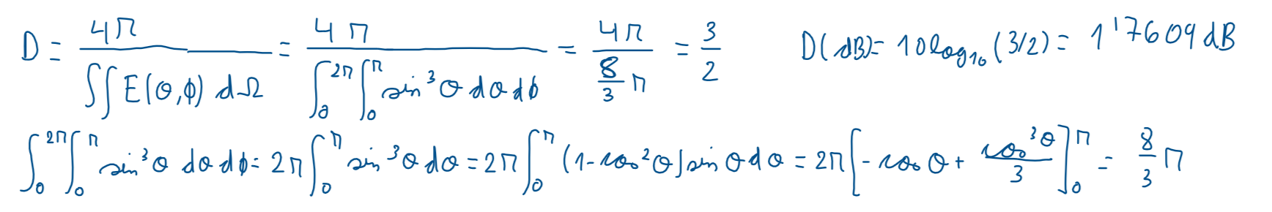
- Using the functions extrae_corte.m polar_zx.m and polar_xy.m plot the E-plane and the H-plane of the pre-work antenna.
At the following two figures it can be observed the plots of the H-plane and the E-plane of the field.

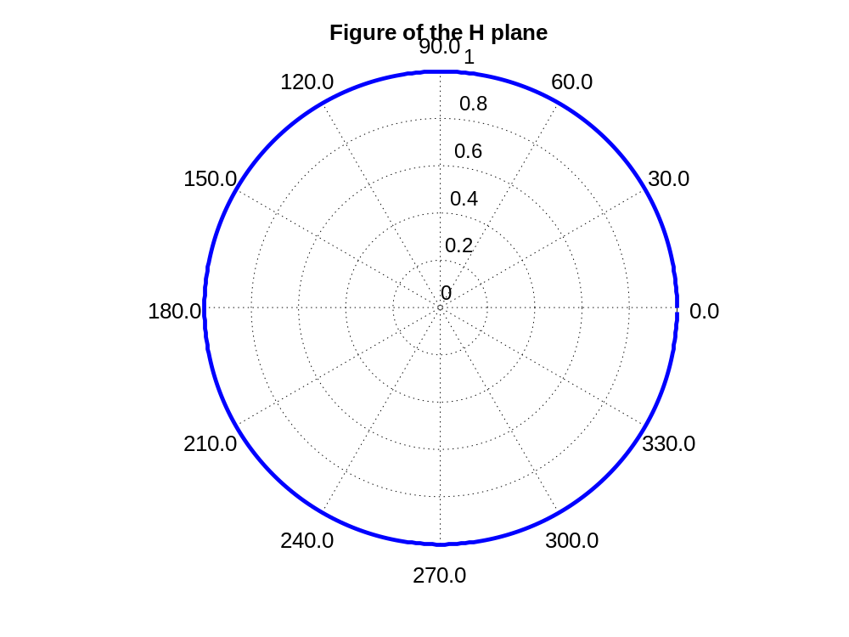
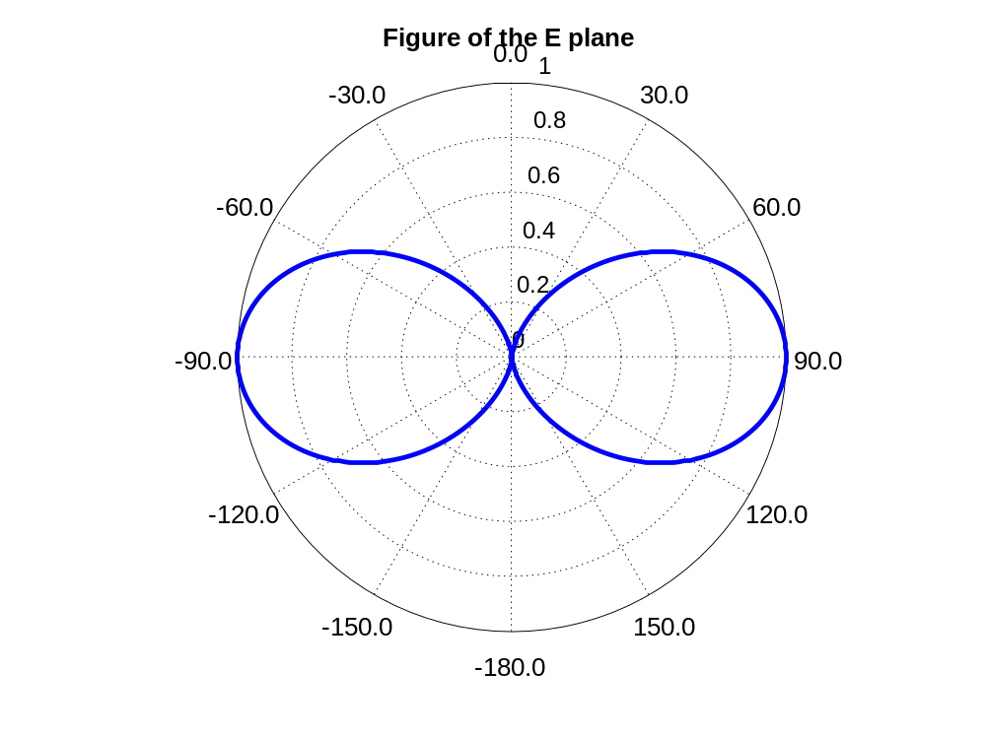
- Repeat for the case:

For this new field the directivity is the following:
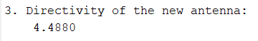
The plots of the E plane and the H plane for the new field are the following:
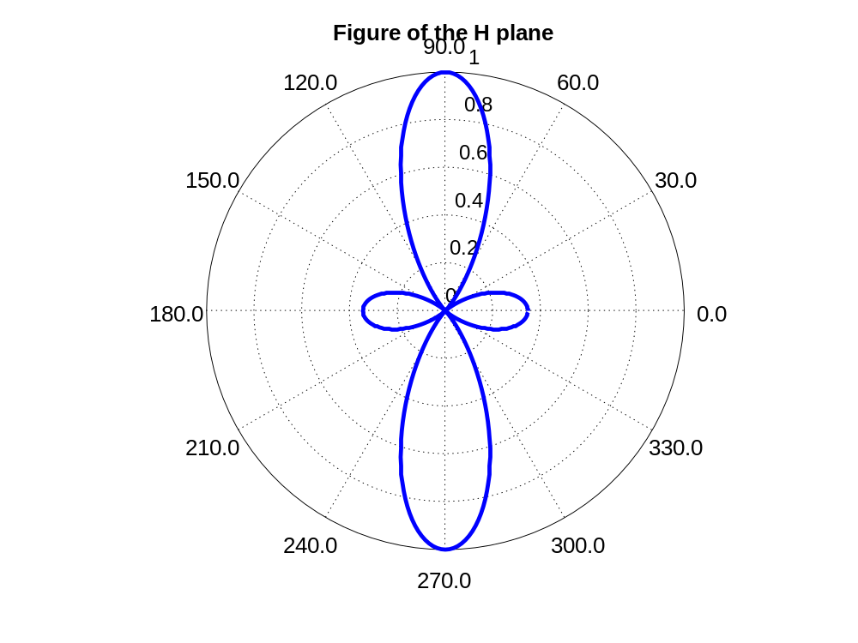
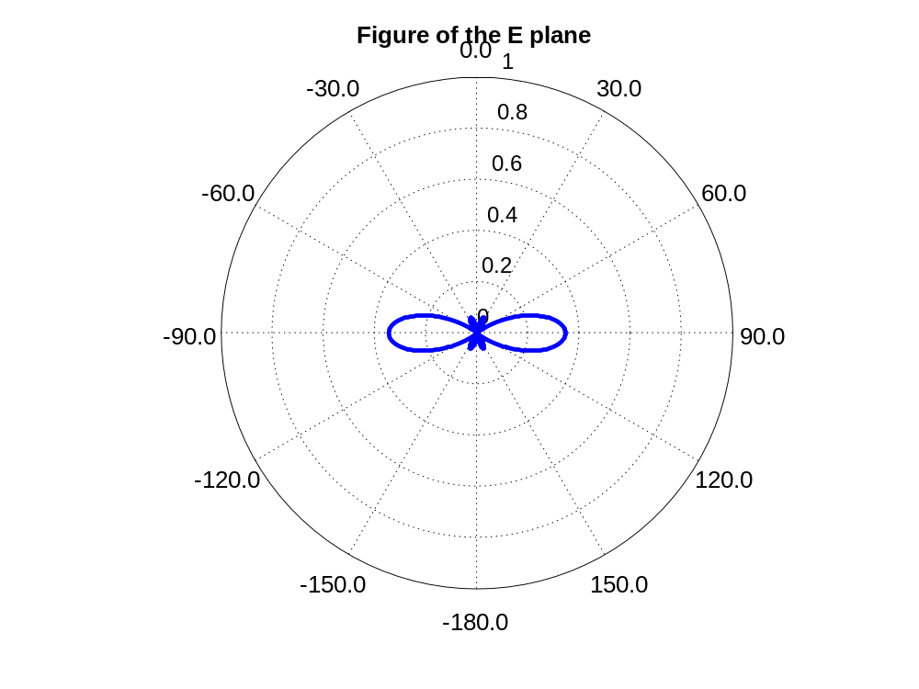

- Using the MATLAB tools of the previous session plot the diagrams of point 4 of the pre-work.
To see the different plots we separate them in three different sections for each different distance:
- Distance=0.25*lambda:
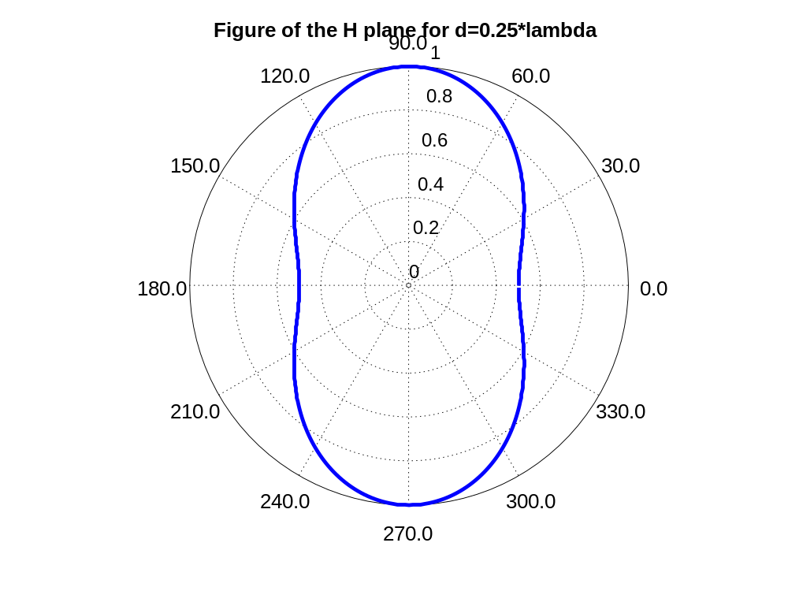
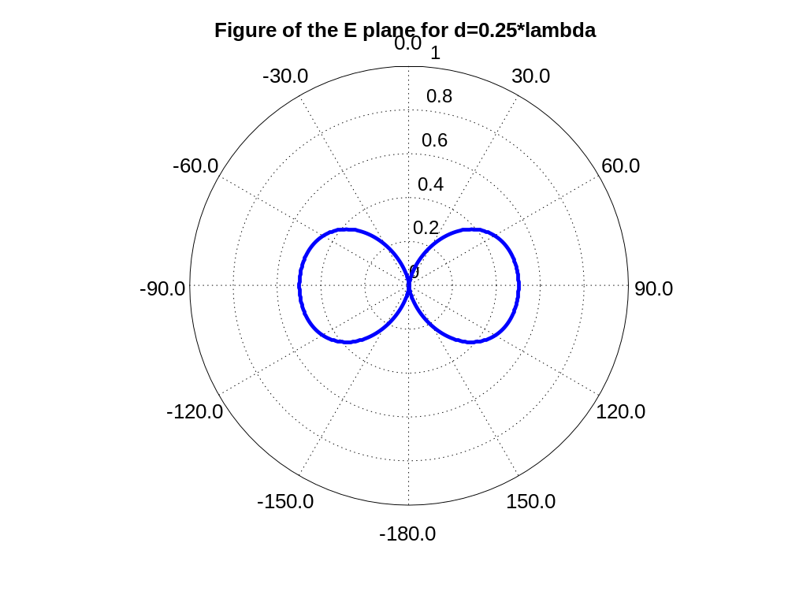
- Distance=0.5*lambda:
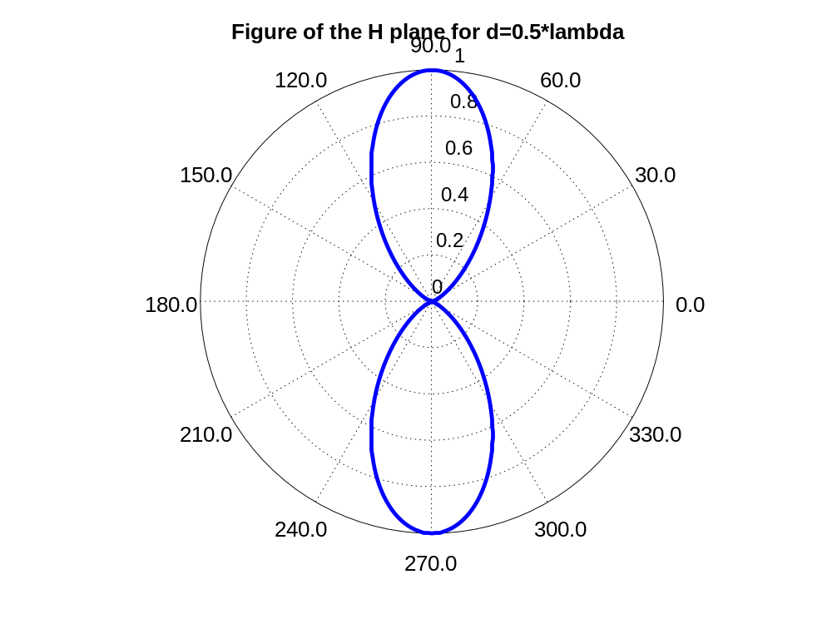
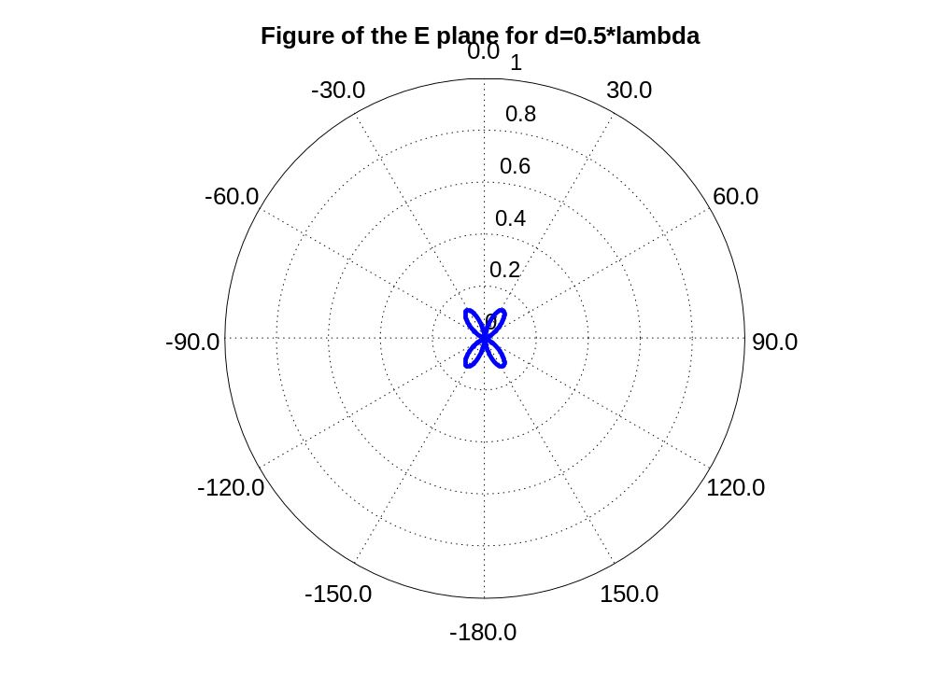
- Distance=0.75*lambda:
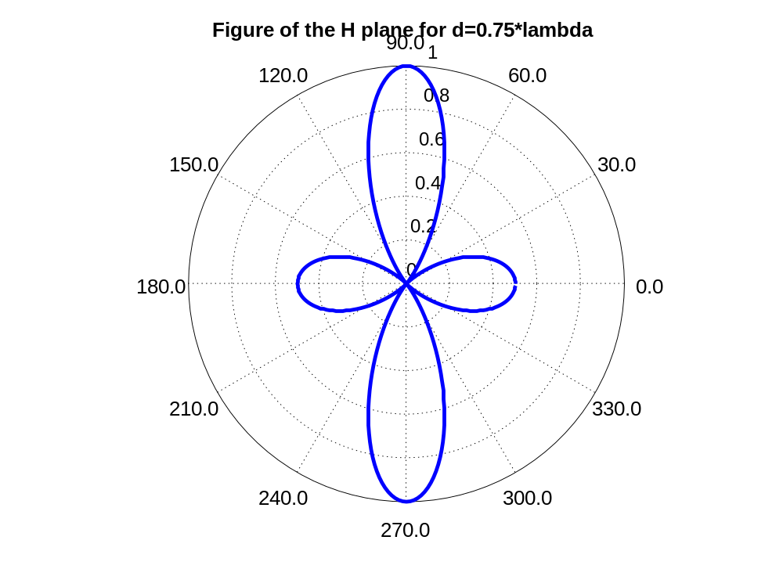
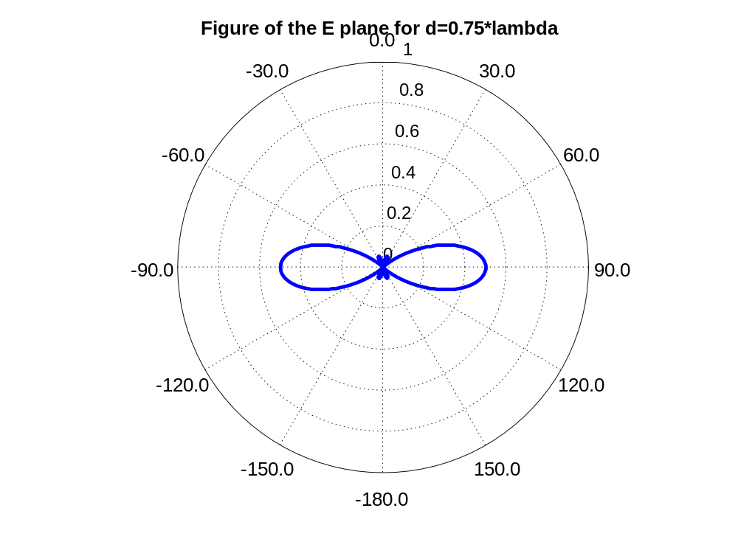
We can see bellow the prework done related to this exercise and we can observe that the plots coincide with the ones in MatLab. 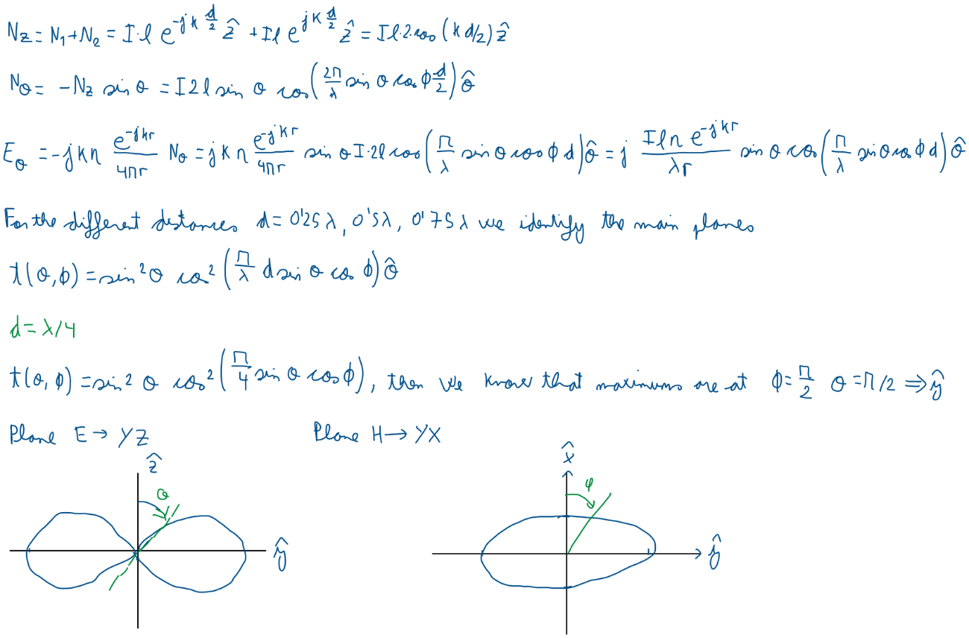
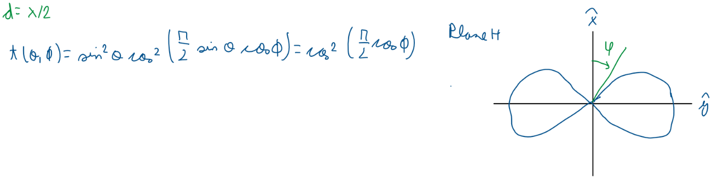

- Repeat the previous case when the currents are in opposite phase. (I2 = - I1).
To see the different plots, we separate them in three different sections for each different distance:
- Distance = 0.25*lambda:
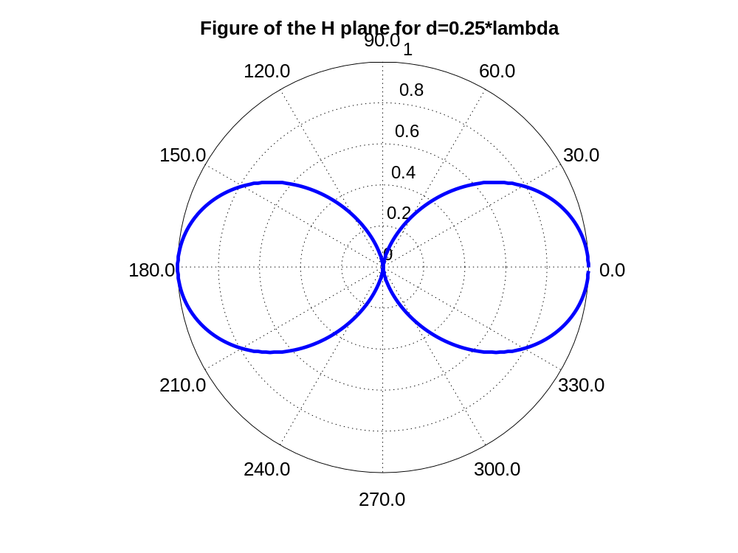
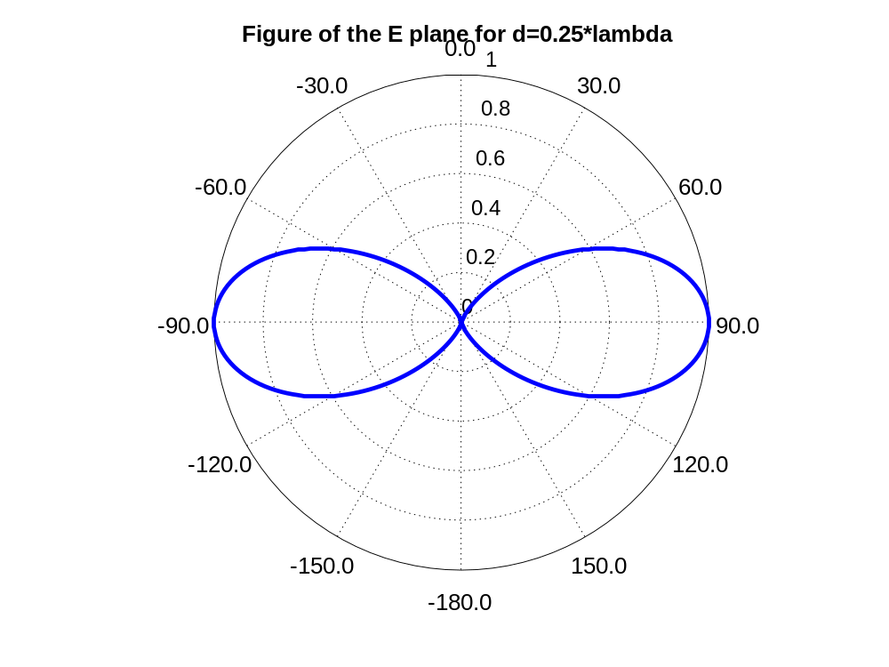
- Distance = 0.5*lambda:
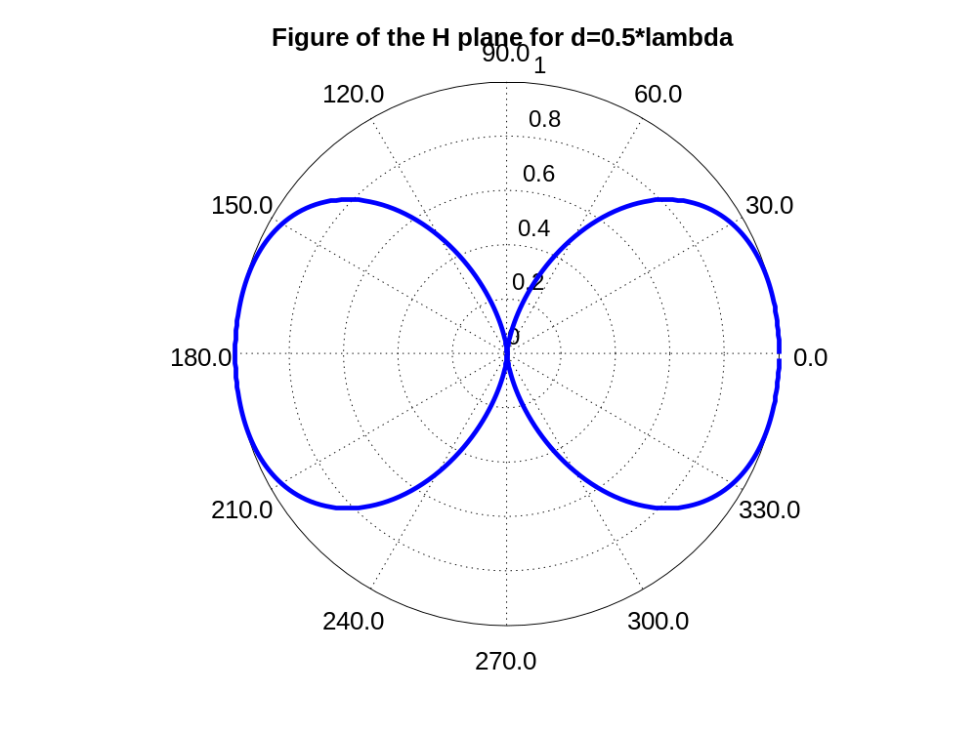
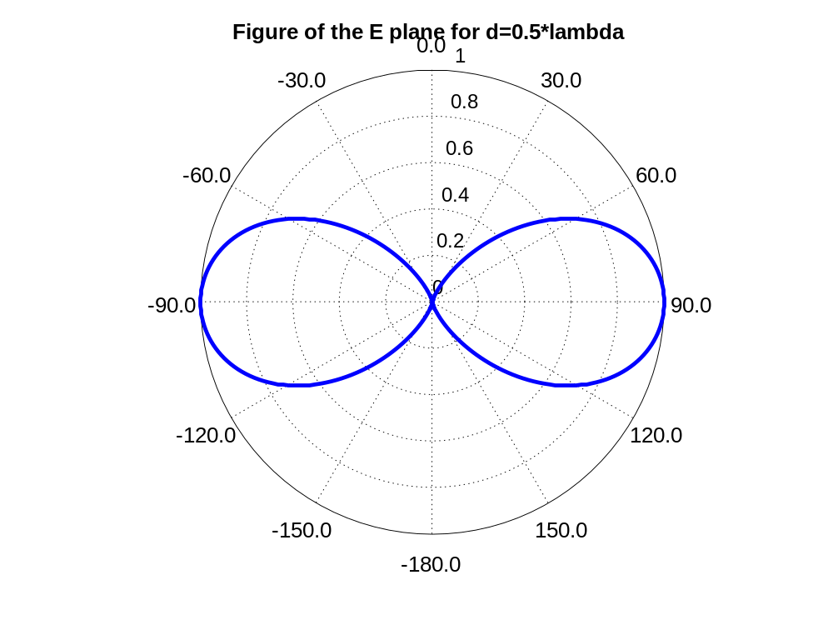
- Distance = 0.75*lambda:
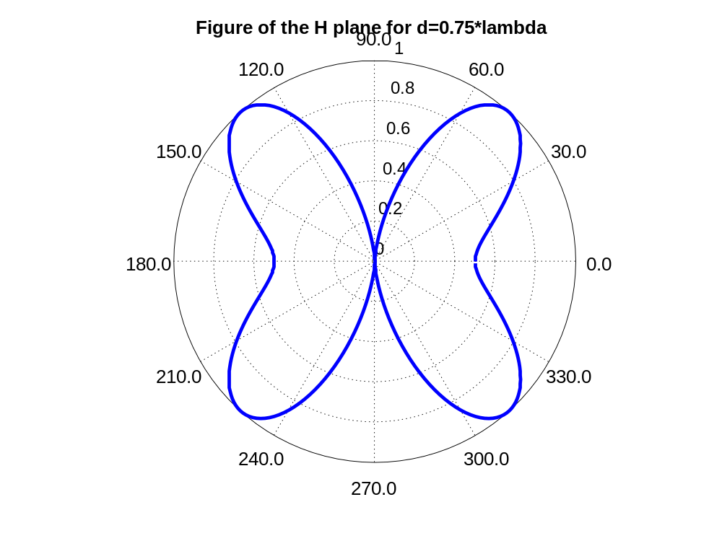
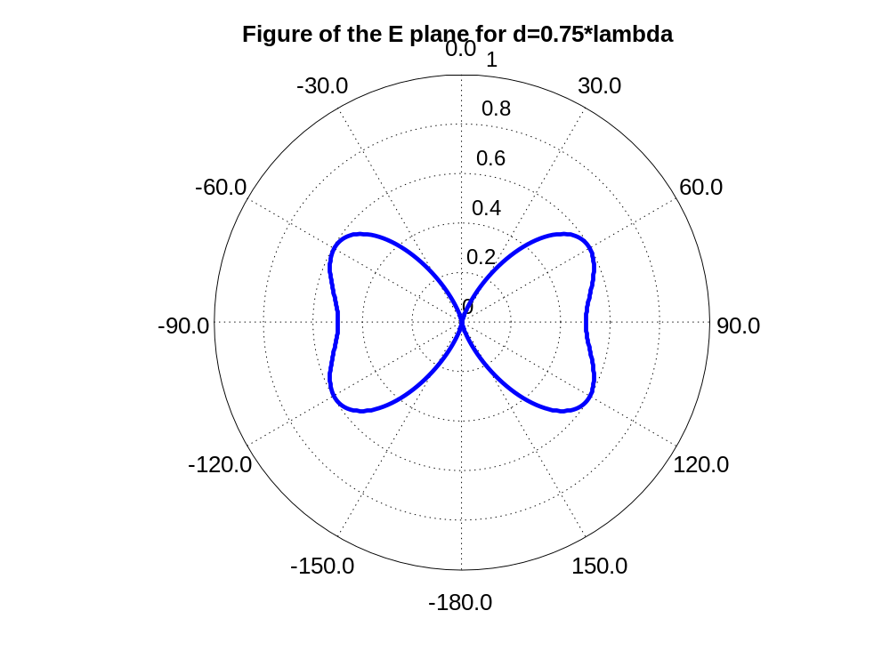
As we can see on all the figures, the plots correspond to the fields generated.

Analysis of large antennas as the superposition of elemental contributions.
- For an antenna of length 2H=0.5λ plot the E-plane and find the directivity of the antenna.
The directivity of the antenna is the following:
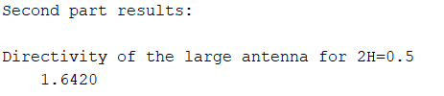
The plot of the H-plane and the E-plane can be obtained following the provided script and produces the following results:
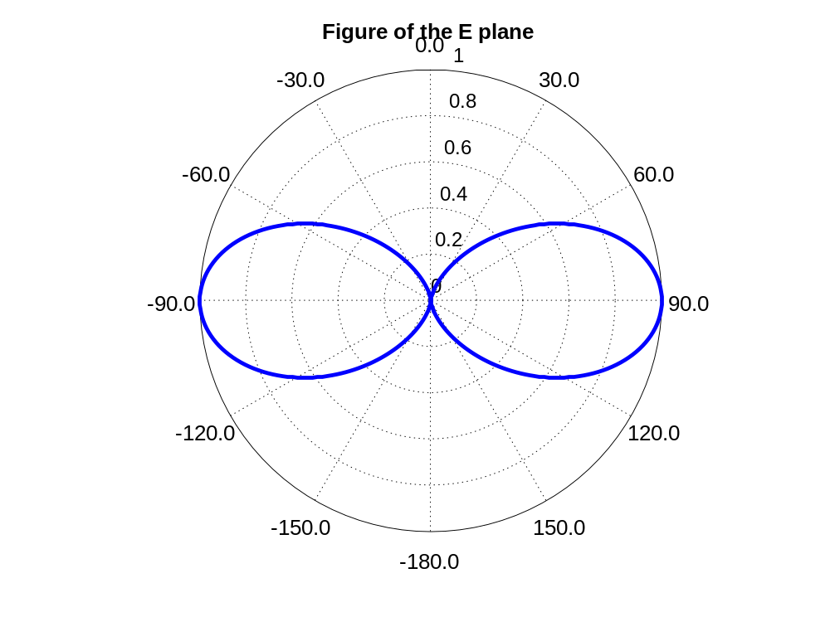
- Repeat for 2H=3λ/4 and 2H=λ.
For 2H=0.75*lambda, the directivity of the antenna is the following:
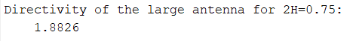
The plot of the H-plane and the E-plane can be obtained following the provided script and produces the following results:
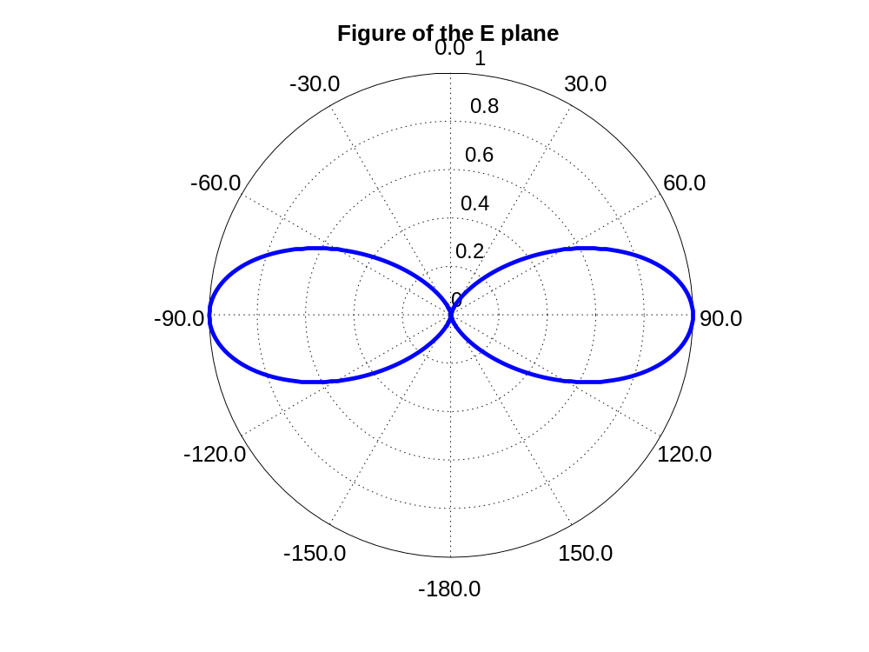
For 2H=0.75*lambda, the directivity of the antenna is the following:
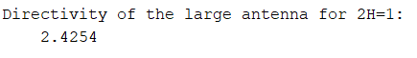
The plot of the H-plane and the E-plane can be obtained following the provided script and produces the following results:
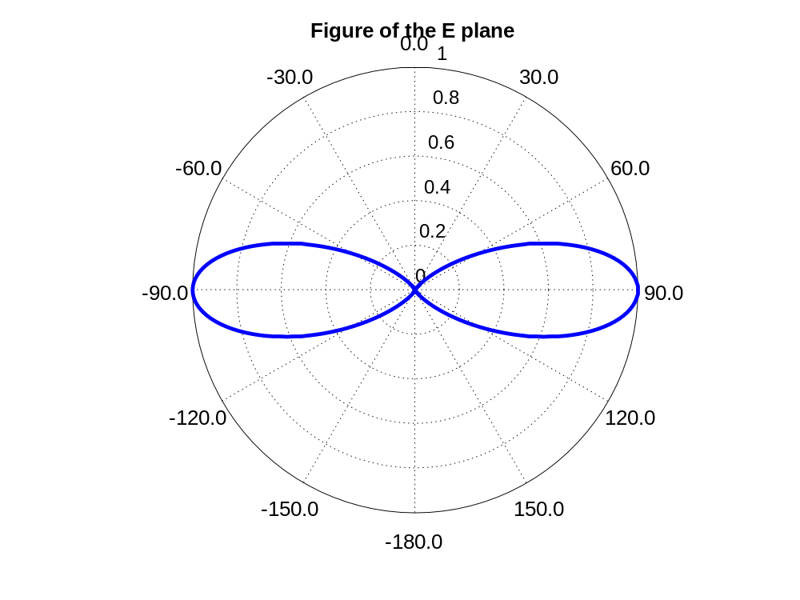
- Plot the evolution of the directivity D as a function of 2H for values between 0 and 1.5λ.
To do this plot we need to do a for to be able to calculate the different values of the directivity. With this process we obtain the following plot with a maximum of directivity of 3.2981:
